2B Displaying Single Data Sets – Lesson 2
Statistics – Radar Plots.

Name: _________________
- When do we use a radar plots?

- Go to http://www.bom.gov.au/climate/averages/tables/cw_060026.shtml and plot Port Macquarie’s weather statistics on a radar chart.

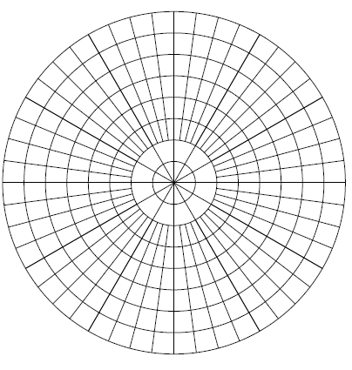
a) Mean Number of Clear Days b) Mean Temperature
J
F
M
A
M
J
J
A
S
O
N
D
4
8
12

- Red Lea chicken factory wants to record the number of chickens processed in there tens of thousands. The results are Jan – 10, Feb – 15, Mar – 25, Apr -27, May – 30, Jun – 45, Jul – 40, Aug – 35, Sep – 25, Oct – 20, Nov – 10, Dec – 20. Plot the results on a radar chart.

